1. In the Management Console type EC2 in the search box and select EC2

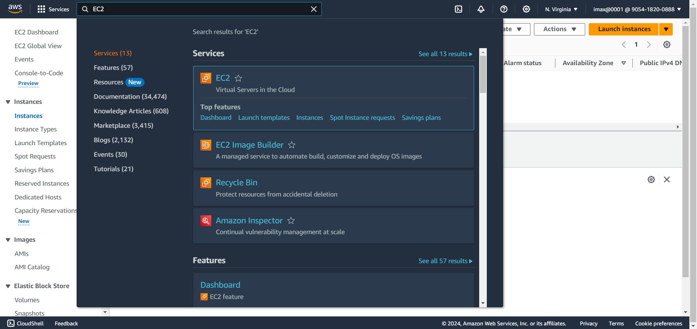

1. In the EC2 dashboard on the left side come down to Network and Security, We are going to select Key Pair

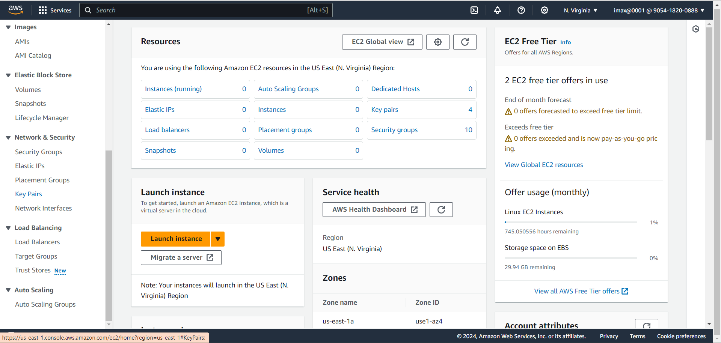

1. Then Select Create key pair

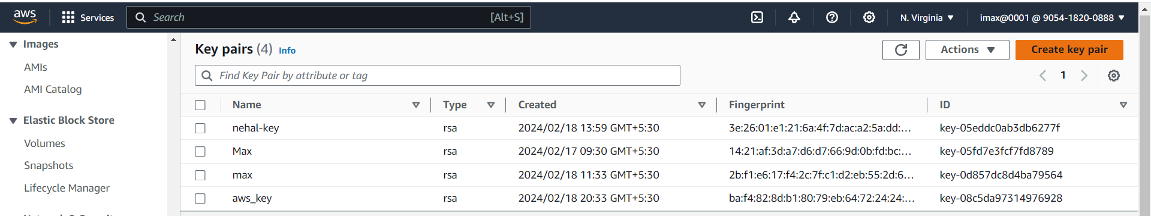

1. Give our Key pair Name(my-ec2key), Key type is RSA and under Private key format make sure you select the .pem, after that click on create Key pair

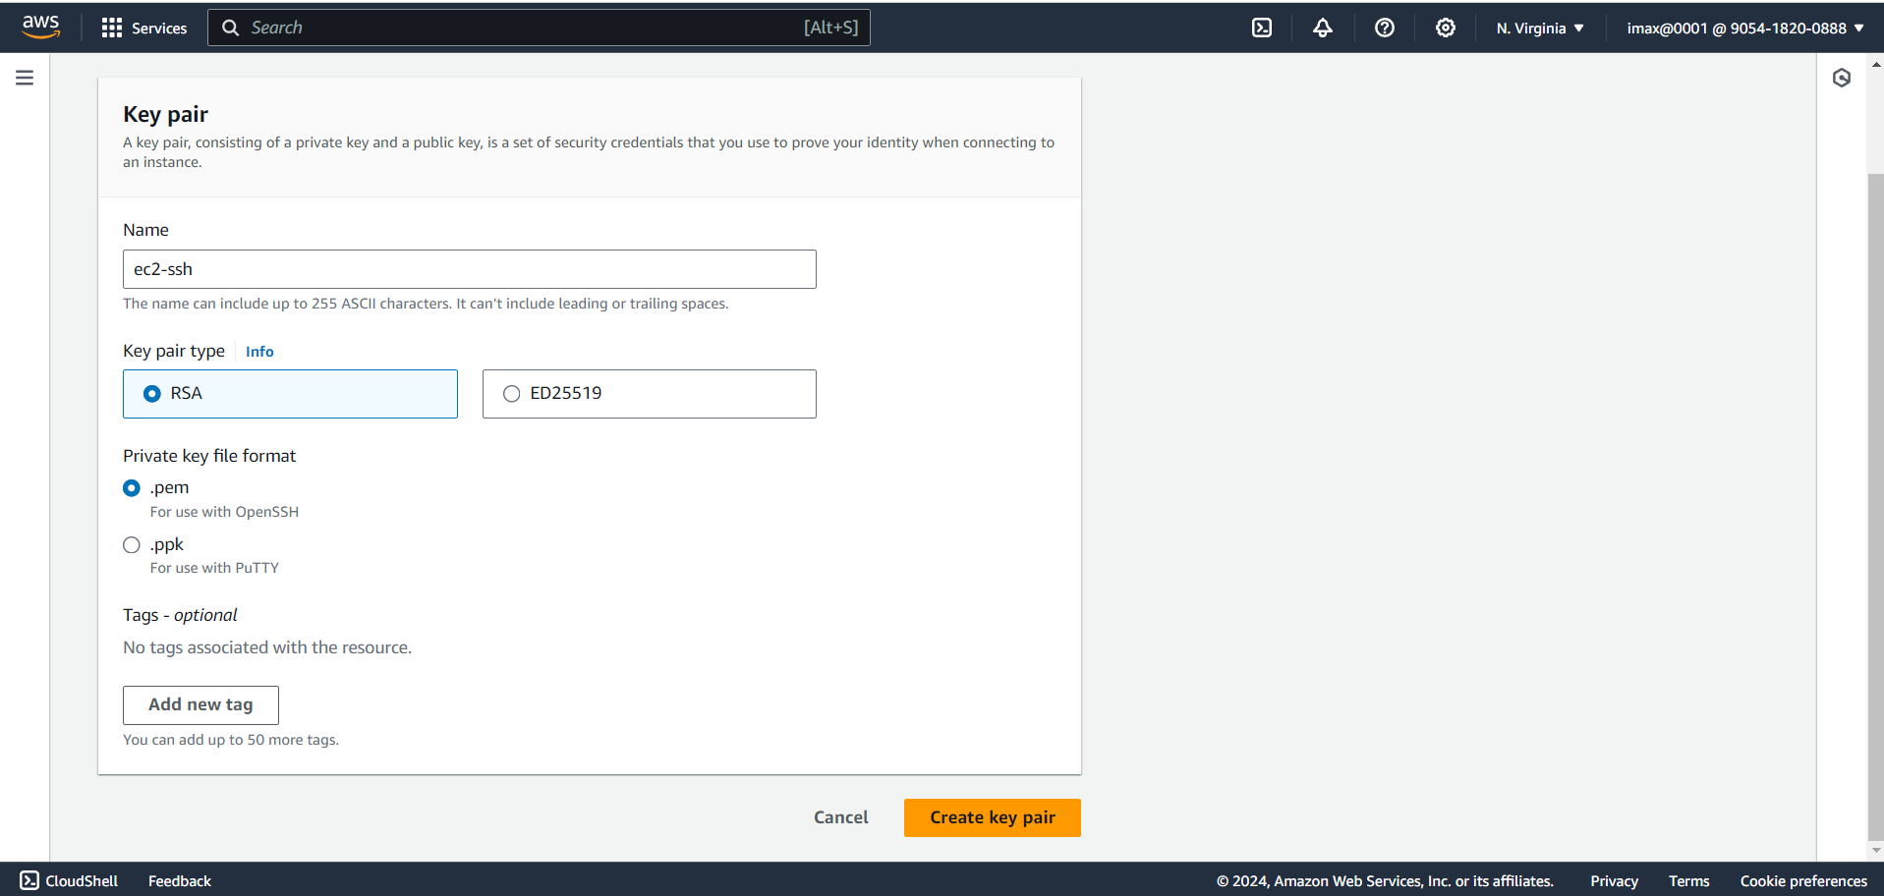

1. We successfully create key pair

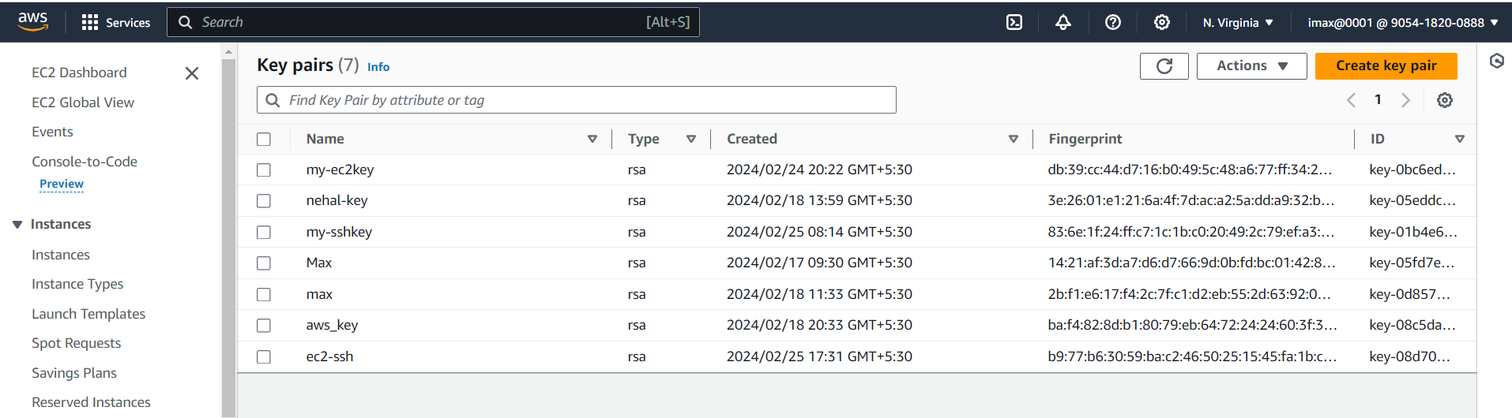

Any time we create key pair two keys will be generated; the key we are seeing in the management Console this is called the public key.

And this is the key we upload to our EC2 instance when launch it the key that is downloaded to My Computer this is private key and this is the key we need to be able to ssh into our EC2 instance(That is 1st thing we need to create a key pair and the format of the keypair needs to be pem

1. Open PowerShell on our computer> Click the start menu here then type PowerShell you are going to see the windows PowerShell icon  Select it

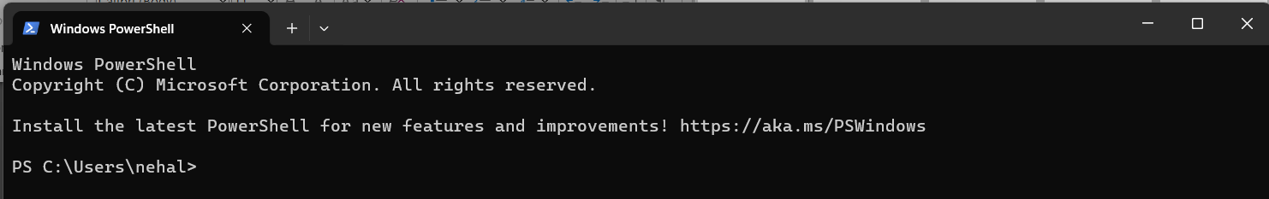

Here this is the current folder my PowerShell is in so this is saying my current folder is the admin folder in my computer if I go to the C driver there will be a users folder in C drive and in that users folder there will be an Admin folder(nehal)

1. Then the pem file we downloaded to our computer we have to put it in this admin folder

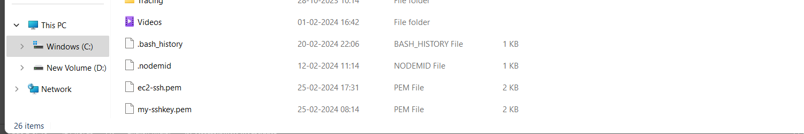

Once it done that just close it

1. Now we need to do is launch our EC2 instance> going to dashboard >on EC2 dashboard I am going to launch a new instance, click Launch Instance
2. Select Ubuntu (Amazon Machine Image)

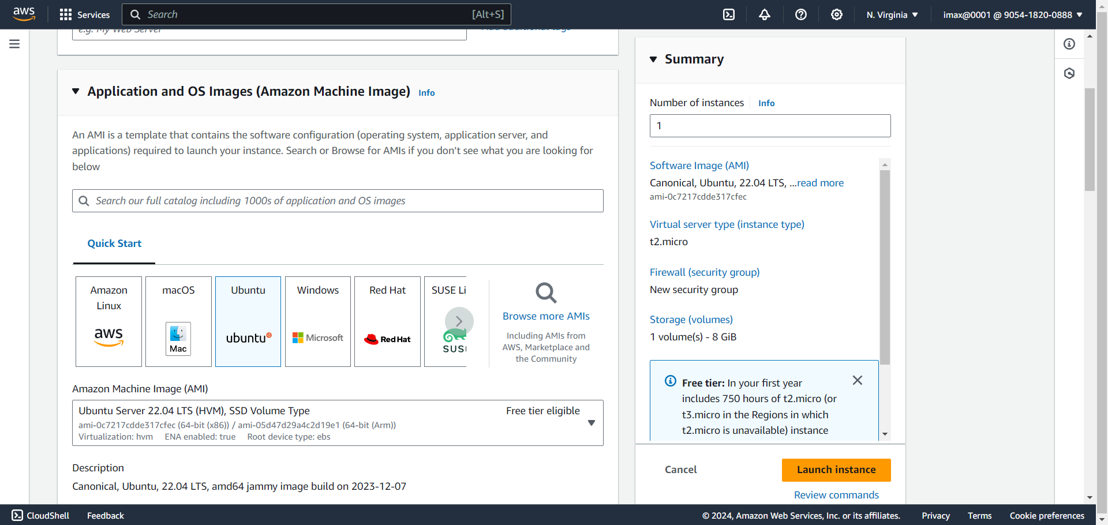

Instance type is t2. micro

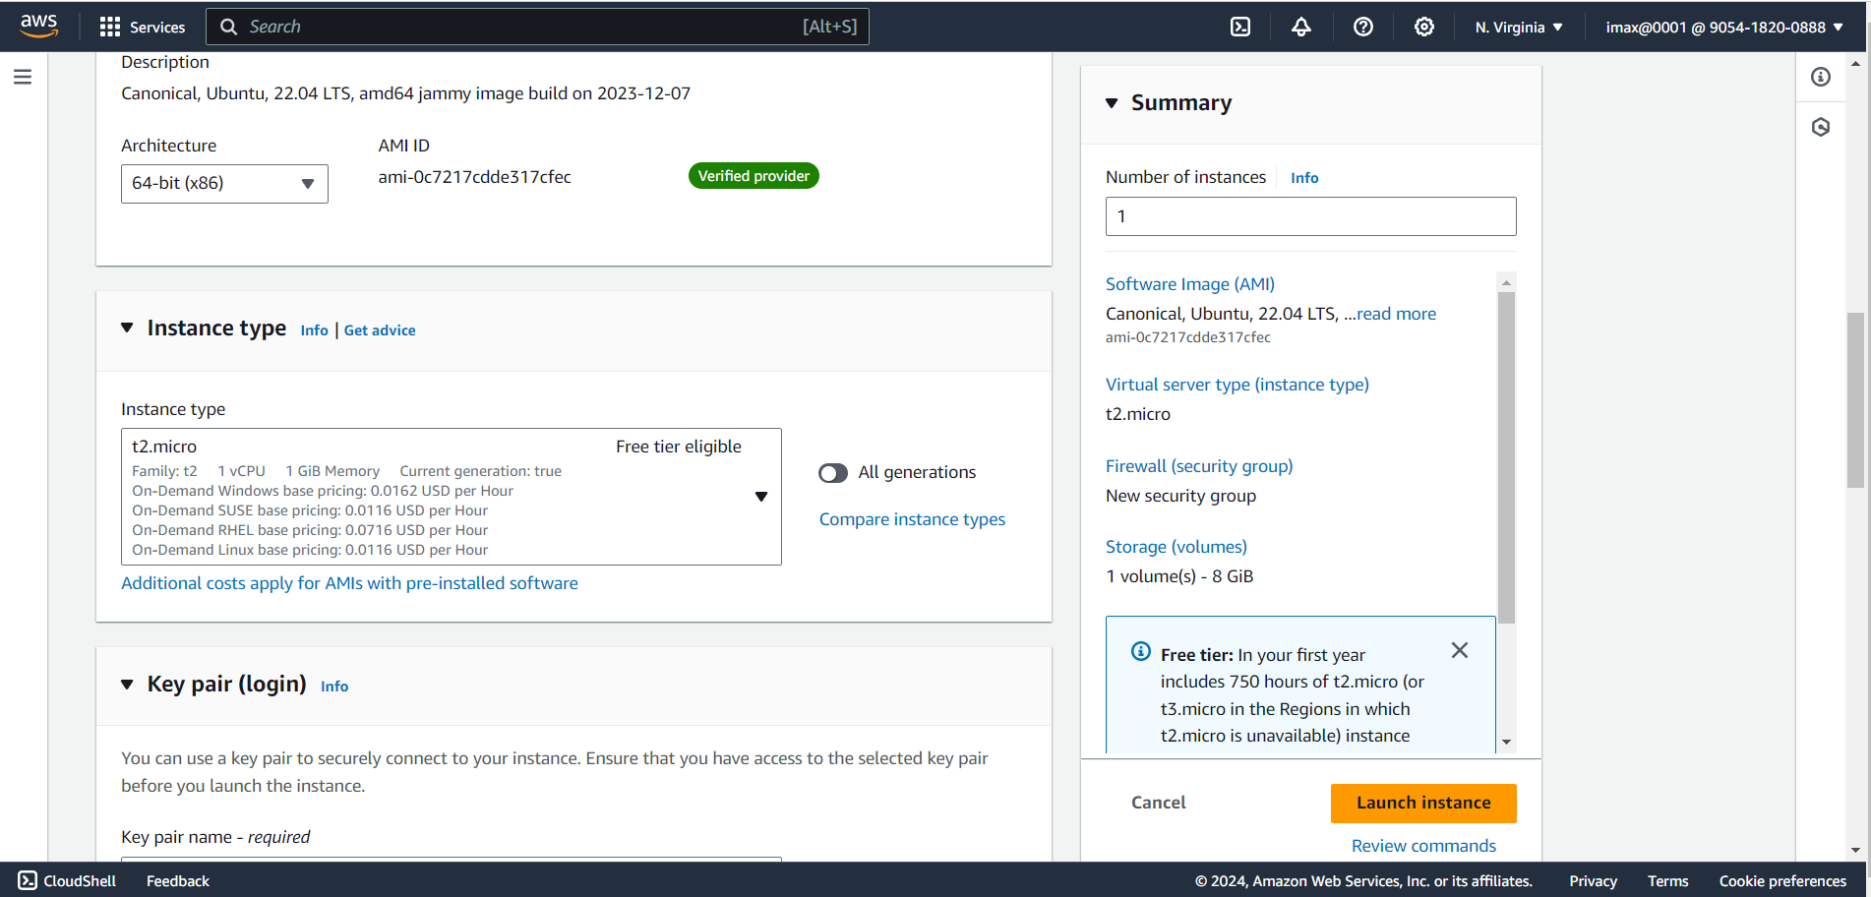

Select we created key pair

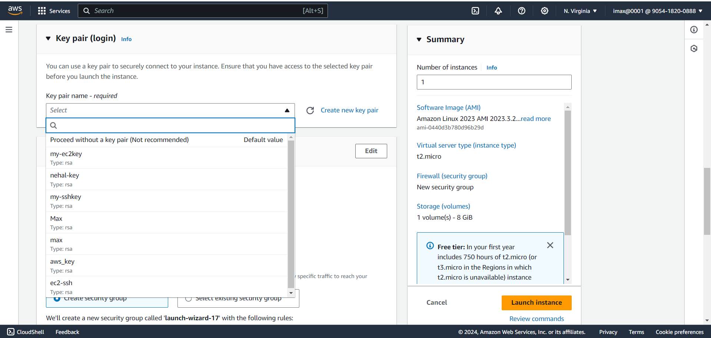

Select default Network Settings

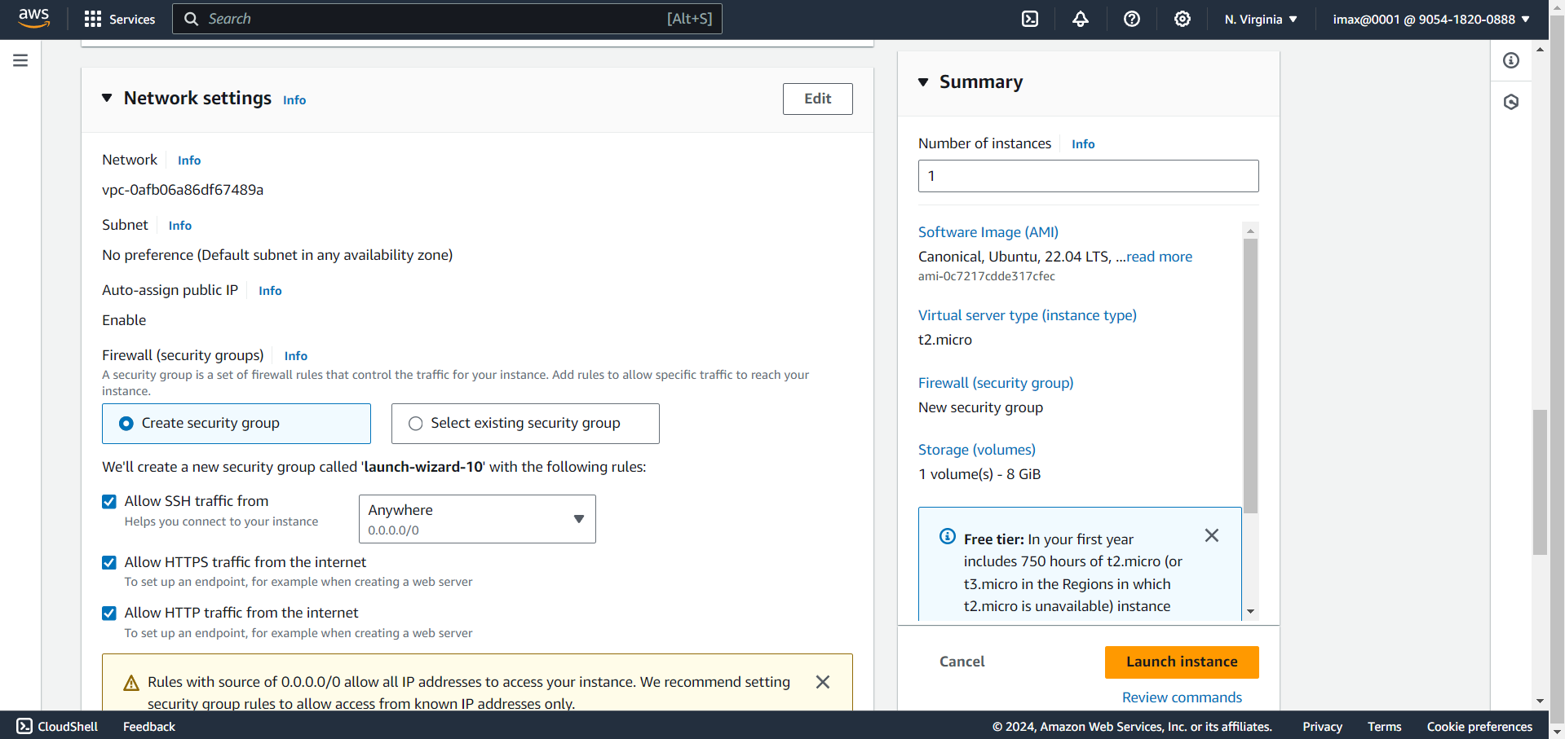

Select default Configure Storage and click on Launch instance

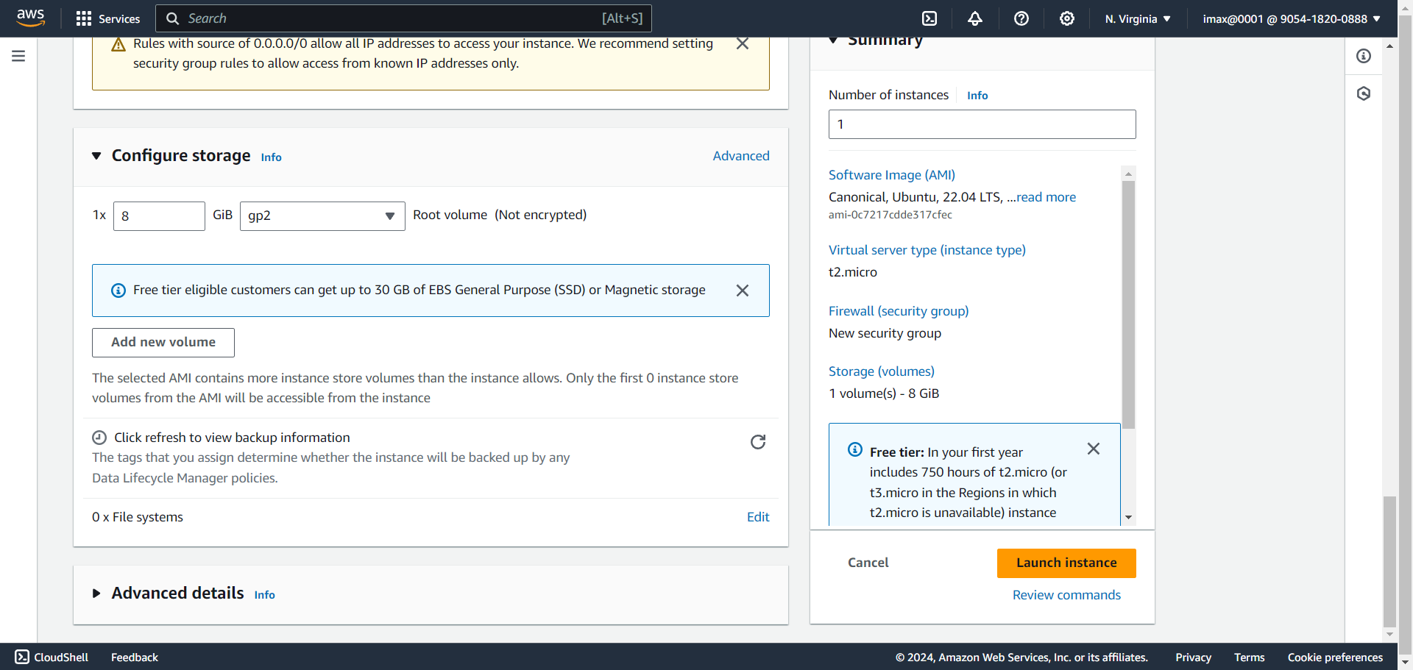

Successfully launce the instance

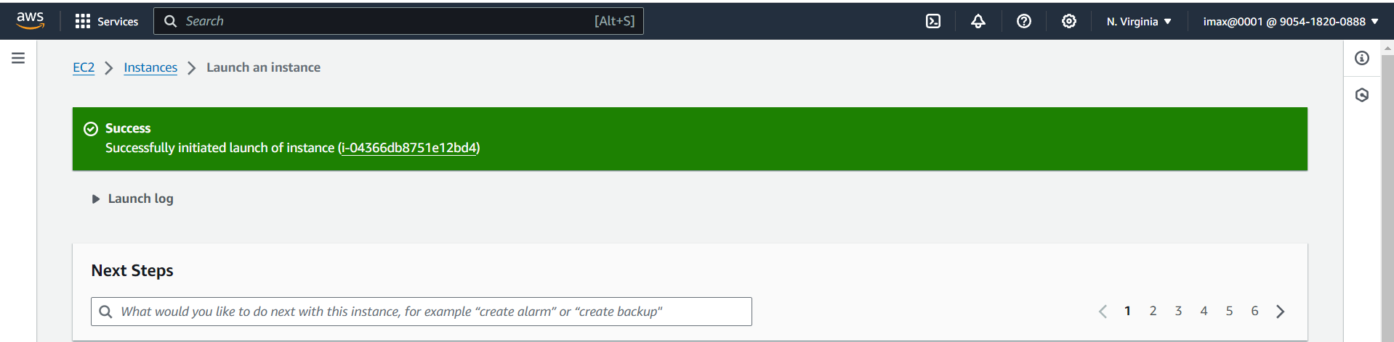

Then View all instance

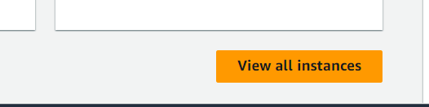

Once the state has changed to running then click on instance checkbox and copy the public Ip

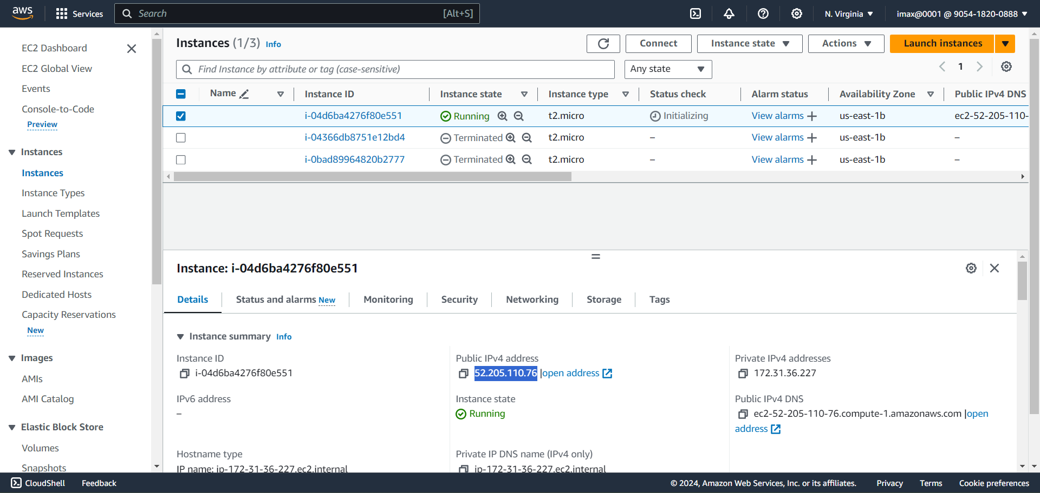10. we are going to open PowerShell (Once we open the windows PowerShell remember that the current directory, we are in needs to be the same directory where we put the pem file in my case I put my pem file in the admin(nehal) directory and that is the current directory I am in)

So to SSH into my EC2 instance type “ssh -i ec2-ssh.pem ubuntu@52.205.110.76” press enter

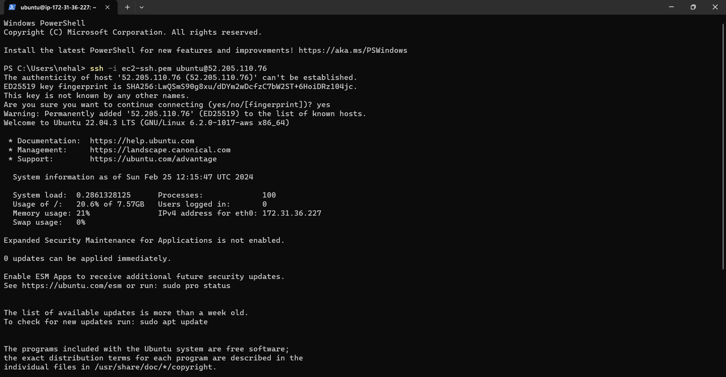

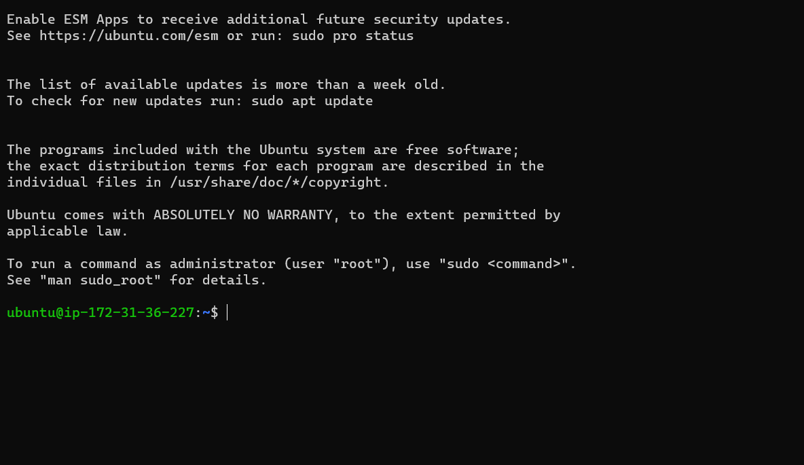

1. Generating key type “ssh-keygen” ;generating on that particular this location

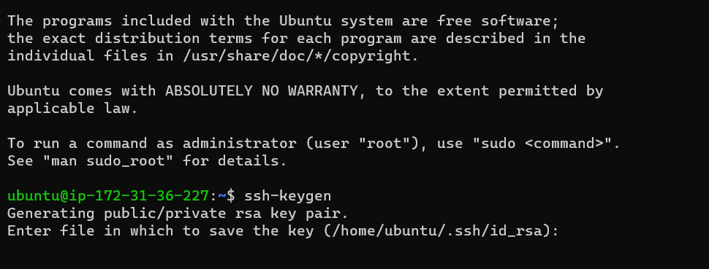

After that press 3 times enter; Now the keys are generated

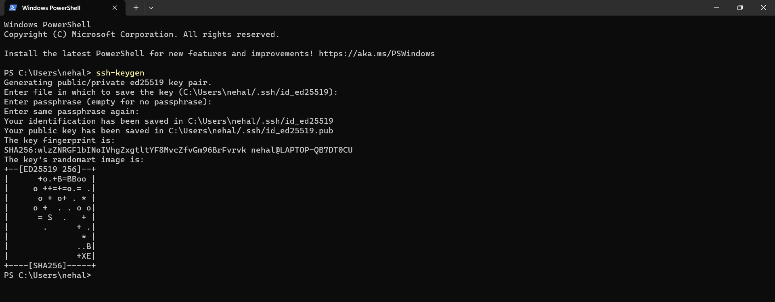

1. Type “dir” : we will see the hidden folder called .ssh

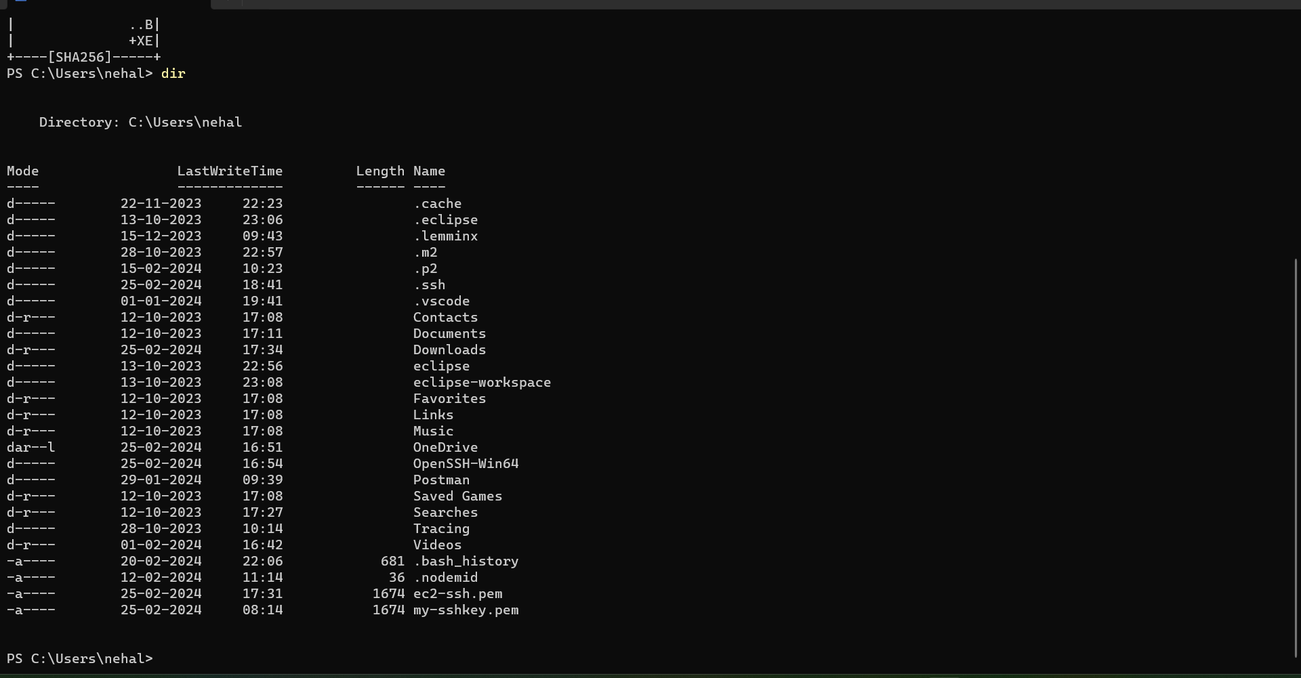

1. Type “dir .ssh”: we can see file ‘id_ed25519’ and ‘id_ed25519.pub’

Once these files are generated this file, we can copy the contents of this files into something called authentication on remote server it will take care of setting up the password as login between the windows machine and remote server

